Category-GuestPost
Company-General Informative
Keyword-Repair damaged PST file after Outlook Profile gets corrupted

Note: Keywords used are highlighted in green throughout the article.

Keywords:
repair damaged pst file, repair damaged outlook archive, outlook profile not loading, how to repair damaged pst file outlook 2013, corrupted pst file, repair a corrupt pst file, how to repair a damaged .pst file in outlook 2010, outlook 2010 keeps corrupting, repair damaged pst file outlook 2010 large, repair damaged pst file outlook 2010 password protected, damaged PST data file

How to Repair Damaged PST File after Outlook Profile Gets Corrupted

Nowadays, a lot of people prefer to use MS Outlook because it is a desktop-based email client. They configure multiple email accounts in Outlook for effortless offline use. But, sometimes, Outlook profile gets corrupted because of a repair damaged outlook archive. The user has to repair the damaged PST file to restore Outlook. Therefore, we will discuss how to repair damaged PST file after Outlook profile gets corrupted.

Since users can access emails from Outlook even without internet connectivity. All email data is synchronized and kept as a copy on the hard disk. This is saved as a PST file, which holds a large amount of data. This file can get corrupted because of slow Outlook performance, due to a large amount of application data. Another possible reason could be a send and receive failure. This occurs when there is a synchronization error between the Outlook server and the PST file on disk. Keep reading to find out why it is advised to repair a damaged PST file.

Need to Repair Corrupt Outlook File
A PST file gets corrupted as a result of system failure or synchronization error. Consequently, users report their Outlook profile not loading. They face a lot of problems as their primary email client stops working. Below is a query from an Outlook forum that justifies the need to restore a corrupted PST file.

“This morning when I started Outlook, I could not see emails from my Gmail address. Even though, it was working perfectly yesterday. I tried to open the PST file from the source, but it did not open. I think it got corrupted but I need it urgently for office work. Does someone know how to repair a damaged .pst file in outlook 2010.”

It is an inconvenience for the users when an Outlook profile gets corrupted. The PST data file can be repaired to restore Outlook. In the following sections, we will discuss the various methods to restore Outlook.

Methods to Repair a Corrupt PST file
Outlook stores data in a .pst file which provides the offline access to users. If this PST file gets corrupted, users can choose to manually repair the file. Otherwise, they can use a third-party tool. Both methods are elaborated below.
Solution 1- The first method consists of the manual steps of how to repair a damaged .pst file in outlook 2010.
- Manual Repair in Outlook 2010, 2013, 2016
These steps are applicable to Outlook 2013, Outlook 2016, and Office 365. Following are the methods of how to repair damaged PST file after Outlook profile gets corrupted:
- Open Control Panel>>Mail. The Mail Setup dialog box will open.
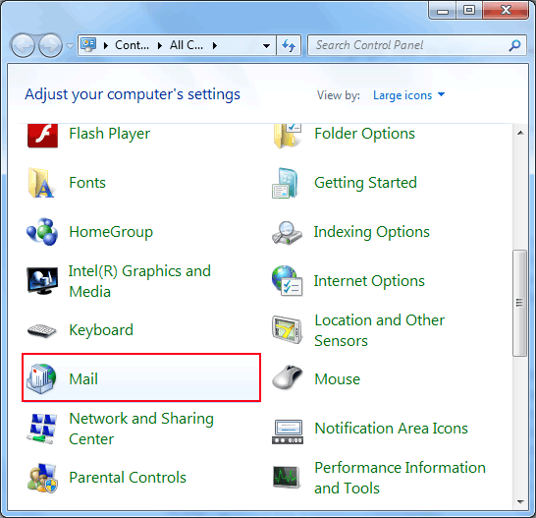

- In the third option, click Show Profiles.
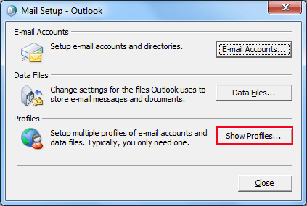

- In the new menu, choose the Outlook option, and click Remove. This will remove the old PST file saved on the computer.
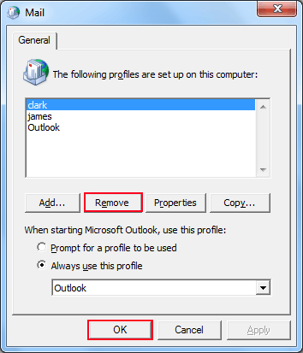

- In the same Window, click Add. This will create a new profile for Outlook on the computer.
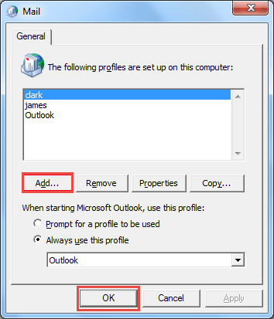

- Name the new profile, and click OK.


Now, start Outlook. Open it with the new profile just created. It should display the contents of the email address you entered.

- For Outlook 2007
The manual procedure for repair is through Outlook 2007 itself. The steps are as follows:
- Open Outlook 2007. Go to Tools>> Account Settings.

- Open the Email tab. Select your account (profile), and click on Repair.

- In the Recovery window, select all the necessary prompts. Restart Outlook when you are done.

Tip: It is recommended to take regular backups of data stored in Outlook. So that in the case of a sudden failure or file corruption, it is easy to restore that data to Outlook. It is a particularly good practice if the data of a large size.

Limitations of the Manual Method:
The manual method of trying to repair damaged outlook archive has the following limitations:
- Does not remember the auto-complete preference of Contacts.
- Cannot successfully repair PST file that has major damage.
- Cannot restore password protected corrupt Outlook data files.

Solution 2- To overcome the limitations of the manual method, users can opt for the Outlook Recovery Tool. The standalone utility will repair a corrupt PST file having minor or major damage, even without Outlook installation. The extracted file can be saved as EML, PST, and MSG on the hard drive. It also supports email recovery of hard deleted and password protected files.

Conclusion
As Outlook handles a large amount of user data on a daily basis, sometimes it gets corrupted. It could be because of hampered Outlook performance resulting from an untoward failure. This blog elaborated the manual method of how to repair damaged PST file after Outlook profile gets corrupted. However, a robust alternative would be to use the Outlook Recovery Tool to repair damaged Outlook archive. The tool recovers all Emails, Calendar, and Contacts, even if the file has major damage. Even large sized PST files can be restored with the tool. Hope this blog helped you in successfully restoring your important data. If you have any queries, leave a comment and we will try to resolve it at the soonest.

